**EC2:** This service helps us in creating Virtual machine (ec2 instances).

Using EC2 we can create

* Linux Servers
* Windows Servers
* Mac Servers (some regions)

To login into

Linux:

* + - SSH Client
    - Credentials:
      * Username and Password
      * Username and Key
    - Ip address/host name

**Lets try to Create a RedHat Linux ec2 instance**

We need to create a Key pair

Public key will be in AWS

Private key will be with us (.pem & .ppk)  
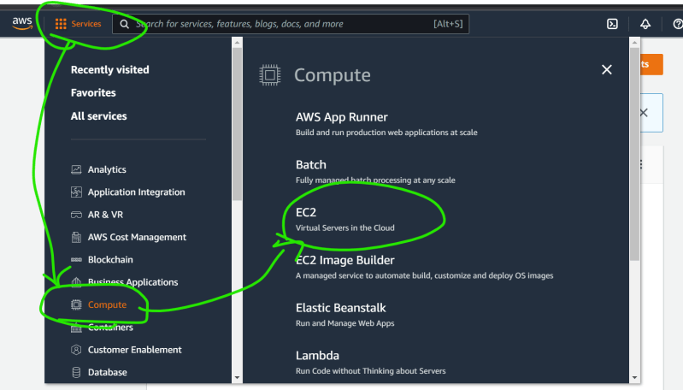  
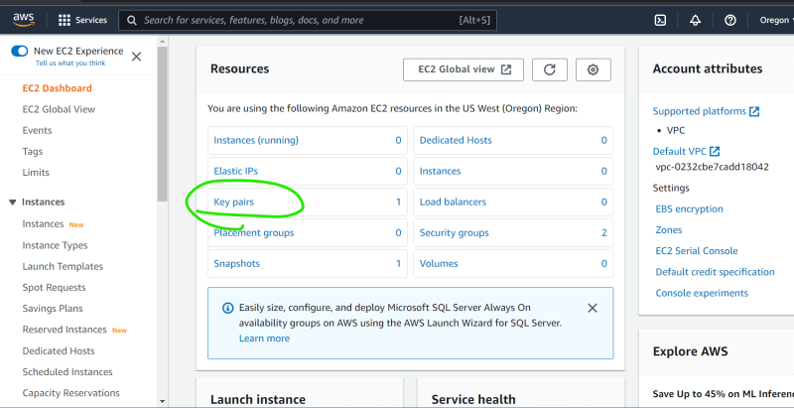  
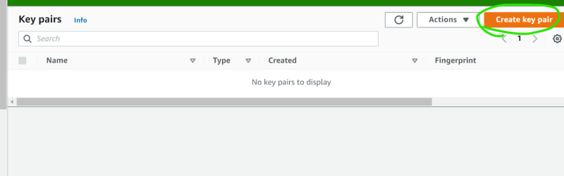  
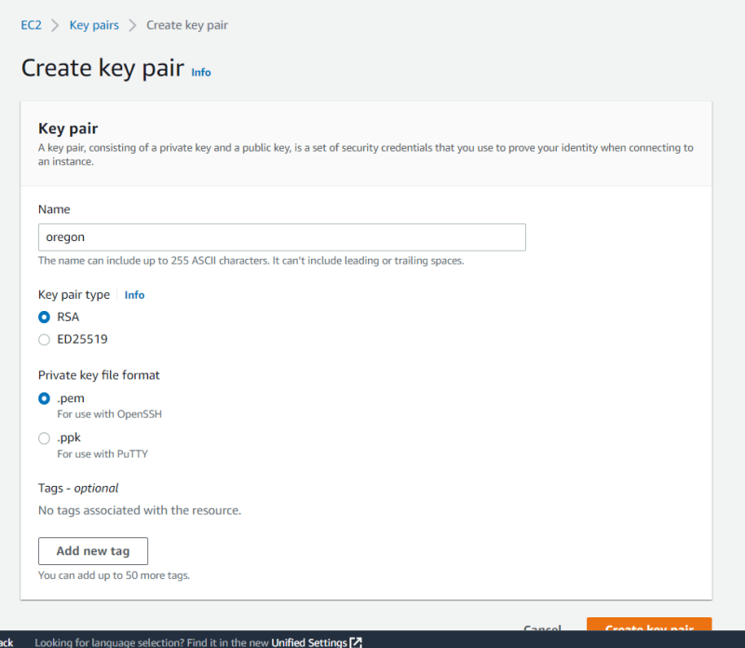  
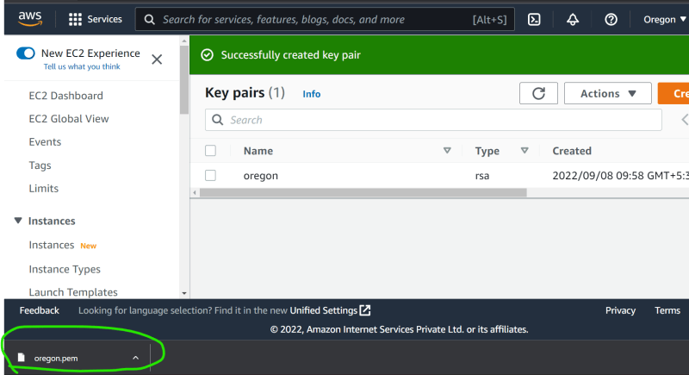

Now lets create ec2 instance (VM)  
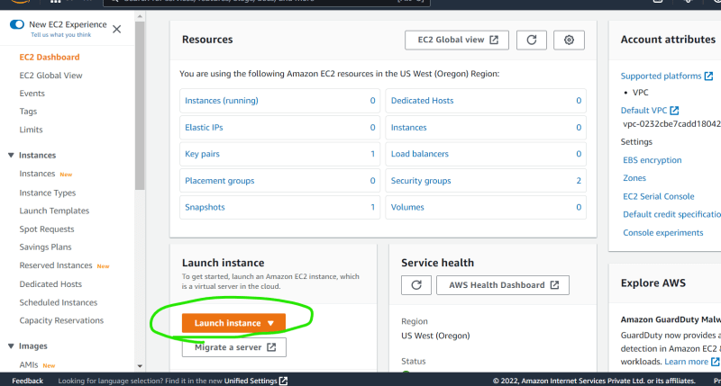  
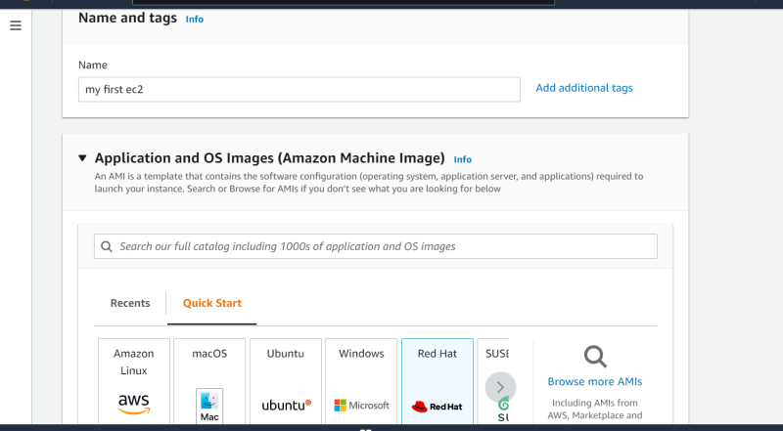  
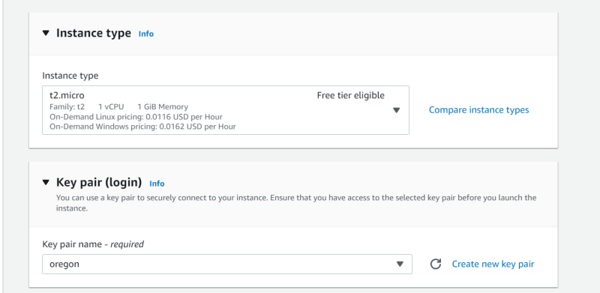  
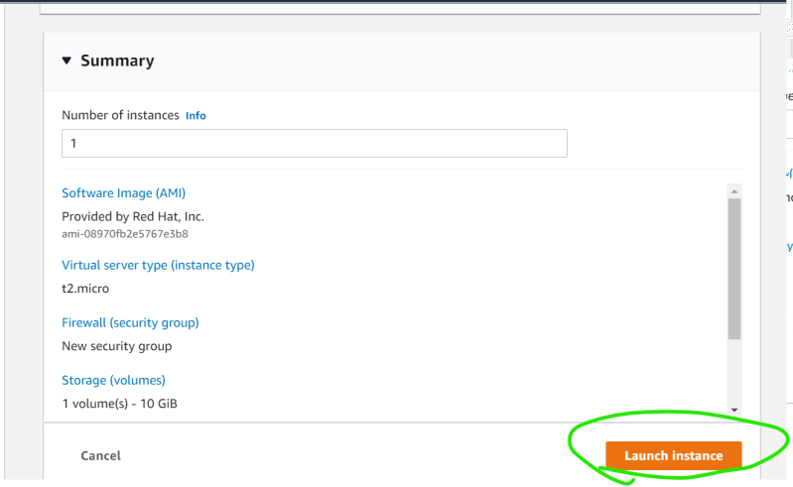  
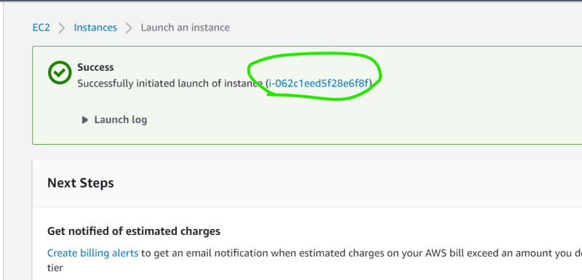  
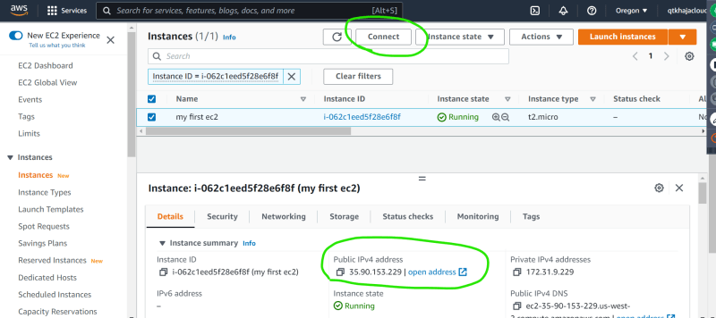

Public ip: 35.90.153.229 and copy the ssh from connect  
